**DIPLOMA IN CULINARY ARTS**



**PROJECT TITLE**

**DESIGN A SUSTAIABLE FOOD TRUCK**

**SUBITTED TO: MS SAYEDA IQRA ALI**

**SUBMITTED BY: MUHAMMAD ABUBAKR**

**BATCH: DCA-120**

**The College of Tourism and Hotel Management, Lahore**

**Project Title**  
*Establishing a Sustainable Food Truck: An Operational and Logistics Framework*

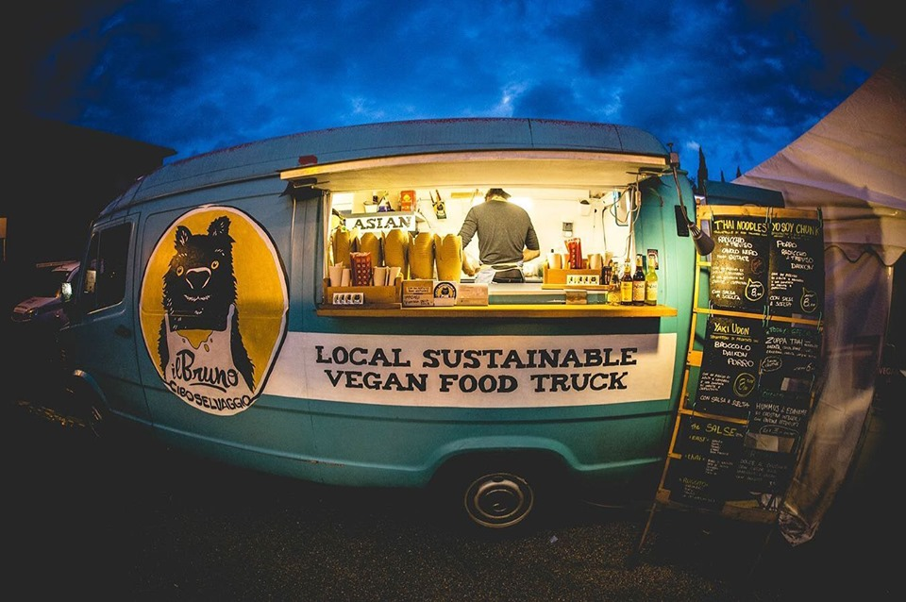

**Table of Contents**

1. **Abstract**
2. **Chapter 1: Introduction**
   * 1.1 Definition and Importance of Sustainable Food Trucks
   * 1.2 Project Purpose and Objectives
   * 1.3 Project Overview
3. **Chapter 2: Literature Review**
4. **Chapter 3: Methodology**
5. **Chapter 4: Findings and Analysis**
6. **Chapter 5: Operational and Logistics Plan**
7. **Chapter 6: Conclusion and Recommendations**

**Abstract**

This project explores strategies to **launch a sustainable food truck venture**, focusing on eco-friendly methods such as responsible sourcing, low-impact operations, and waste reduction. Through analysis of emerging trends and best practices, this research outlines a **step-by-step plan** for entrepreneurs to balance environmental stewardship with financial viability. The findings emphasize the value of building strong community ties, optimizing logistics to cut costs, and consistently measuring sustainability outcomes.

**Chapter 1: Introduction**

**1.1 Definition and Importance of Sustainable Food Trucks**

In recent years, **food trucks** have evolved into popular culinary outlets, offering a variety of foods in unique, **mobile settings**. However, the concept of sustainability within this sector has gained momentum due to growing **environmental awareness** and consumer interest in **healthier, more ethically sourced foods**.

A **sustainable food truck** strives to:

1. **Minimize Energy Usage**: Employ energy-efficient cooking and lighting, or consider alternative energy sources like solar panels.
2. **Source Responsibly**: Purchase local or organic ingredients to support small farms and reduce carbon emissions associated with long-distance shipping.
3. **Reduce Waste**: Use compostable packaging, recycle or donate surplus foods, and manage cooking oil responsibly.

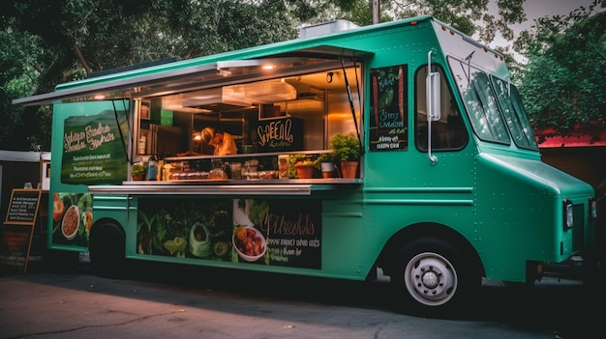

**Figure: Food Truck**

**1.2 Project Purpose and Objectives**

**Purpose**  
The primary aim of this project is to provide a **practical roadmap** for aspiring entrepreneurs looking to establish a **sustainable food truck**. By incorporating eco-friendly measures from the outset, these ventures can contribute to environmental preservation while still remaining profitable.

**Objectives**

1. **Identify Best Practices**: Research established methods for running a green, efficient mobile kitchen.
2. **Develop Operational Guidelines**: Outline daily routines and resource management strategies to maintain profitability.
3. **Analyze Financial Implications**: Determine how to balance upfront sustainability investments with long-term returns.
4. **Propose Logistical Solutions**: Offer insight into effective routing, supply chain coordination, and waste disposal practices.

**1.3 Project Overview**

* 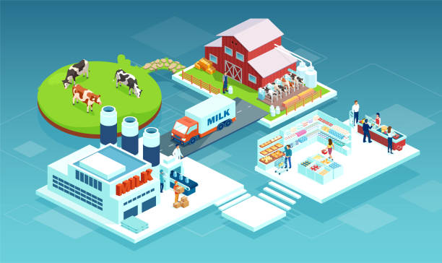**Chapter 2** investigates current literature on sustainability trends and success stories within the mobile food industry.
* **Chapter 3** details the research techniques (such as interviews, surveys, or data analysis) used to gather insights.
* **Chapter 4** presents findings, interpreting them against the backdrop of real-world sustainability challenges.
* **Chapter 5** offers an integrated plan for day-to-day operations, logistics, marketing, and community outreach.
* **Chapter 6** concludes by summarizing key lessons and providing actionable recommendations for future projects.

**Chapter 2: Literature Review**

Research on **sustainable food operations** reveals that local sourcing not only reduces the carbon footprint but also strengthens regional economies (Smith, 2021). Meanwhile, studies by Greenway and colleagues (2022) highlight the importance of **waste management**, indicating that consumer perceptions of eco-friendly practices can significantly influence purchasing behavior. Several **case studies** also note that marketing the “green angle” effectively can attract a dedicated following and position a food truck as a community staple.

**Chapter 3: Methodology**

1. **Data Collection**:

* **Surveys**: Distributed questionnaires to local residents to gauge interest in sustainable dining options.
* **Interviews**: Conducted structured interviews with current food truck owners and local farmers to understand practical barriers.
* **Secondary Research**: Examined government reports, academic journals, and industry publications for data on sustainability metrics.

1. **Data Analysis**:

* **Qualitative**: Assessed recurring themes from interviews (e.g., cost concerns, consumer demand, and operational challenges).
* **Quantitative**: Analyzed survey statistics to gauge market size and potential profitability.

**Chapter 4: Findings and Analysis**

**4.1 Market Demand**

Survey responses indicated a **strong preference** for locally sourced and organically grown ingredients. Approximately 68% of participants expressed willingness to pay slightly higher prices if the truck demonstrated eco-friendly practices.

**4.2 Operational Feasibility**

Interviews with existing food truck operators highlighted **reliable power sources** and **cost-effective routes** as major concerns. Those who invested in solar generators reported lower fuel costs over time, offsetting the initial equipment expenses.

**4.3 Financial Considerations**

A cost analysis showed that while there can be **higher upfront costs** for sustainable equipment and packaging, these expenses can be recouped through **enhanced brand reputation**, premium pricing opportunities, and potential governmental incentives or subsidies in some regions.

**Chapter 5: Operational and Logistics Plan**

1. **Truck Setup**

* **Energy**: Install a solar panel system or an energy-efficient generator to reduce ongoing fuel usage.
* **Equipment**: Opt for induction stovetops and LED lighting to minimize electricity demand.

1. **Sourcing and Inventory**

* **Ingredient Procurement**: Partner with local farms and co-ops for fresh, seasonal produce.
* **Storage**: Use chilled containers specifically designed for mobile kitchens to reduce food spoilage.

1. **Route Optimization**

* **Software Tools**: Invest in route-mapping applications to plan efficient service locations and reduce fuel consumption.
* **Pop-Up Events**: Coordinate with community gatherings or farmers’ markets to reach target demographics easily.

1. **Waste Management**

* **Composting**: Transform organic scraps into compost, potentially collaborating with community gardens.
* **Recycling**: Dispose of plastic, glass, and metal responsibly, and repurpose cooking oil as possible.

1. **Marketing and Community Engagement**

* **Social Media**: Share behind-the-scenes highlights of sustainable practices to build customer loyalty.
* **Community Partnerships**: Support local causes or environmental clean-up events to enhance public image.

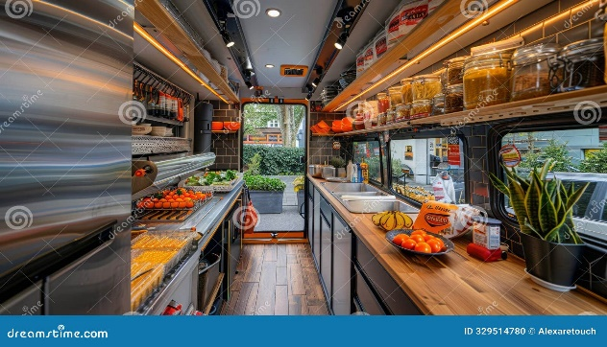

**Chapter 6: Conclusion and Recommendations**

Sustainable food trucks have the potential to **transform urban dining** by promoting healthier options and reducing carbon footprints. To succeed, entrepreneurs must combine **environmental best practices** with solid **business acumen**. This includes carefully selecting energy-efficient equipment, building **local supply chains**, and engaging with the community through transparent marketing. Future research could focus on **technological advancements** (like battery-powered trucks) or the **long-term impact** of supportive government policies on small, mobile food businesses.

**Key Recommendations**

* Continuously monitor energy usage and **invest in alternative power sources**.
* Develop lasting relationships with local producers to secure **fresh, high-quality ingredients**.
* Implement a **visible waste management program** (e.g., compost and recycle bins) to showcase eco-consciousness.
* Use **targeted marketing** to educate customers about sustainability, reinforcing **brand loyalty** and profit margins.